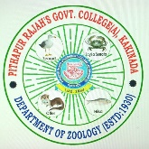**PITHAPUR RAJAH’S GOVERNMENT COLLEGE(A)**

**KAKINADA-533 001, AP-533001**

**REACCREDITED BY NAAC WITH ‘A’ GRADE**

**DEPARTMENT OF ZOOLOGY & AQUACULTURE**

**Event name: CAREER GUIDANCE FOR BZC and CZAC/ZOOLOGY STUDENTS and ORIENTATION FOR PGCET**

|  |  |  |
| --- | --- | --- |
| **1** | **Date of activity** | 29-03-2025 |
|  | **Objective** | To provide inputs on the opportunities and to motivate UG students to opt for PG studies |
| **2** | **Conducted by** | Department of Zoology & Aquaculture. |
| **3** | **Nature of the Activity**  **(Seminar/Workshop/Extension lecture etc.)** | Awareness programme on career Guidance |
| **4** | **Title of the Activity** | **PROSPECTS AND OPPURTUNITIES FOR BZC\ZOOLOGY students** |
| **5** | **Details of Resource person**  **(Name, Designation etc.)** | Sri. B.chakravarthi Hod of Zoology & Aquaculture  Dr. B. Elia, Ms.Y. Gowthami, Ms. SV Lakshmi and all faculty |
| **6** | **No. of Students Participated** | 65 |
| **7** | **Brief report of the activity** | The Department of Zoology and Aqua Culture Conducted This Programme for Final Year Students. Department Hod B.Chakravarti and remaining Faculty created awareness. A range of career opportunities with objectives are cantered around animal sciences, conservation, and environmental management.  challenges like climate change and food security. |
| **8** | **Name of the lecturers who planned and conducted the activity** | Sri. B.chakravarthi Hod - Zoology & Aquaculture |
| **9** | **Remarks, if any** |  |
| **10** | **Signature of the Lecturer in charge/**  **Convener of the committee** |  |
| **11** | **Signature of the Principal** |  |

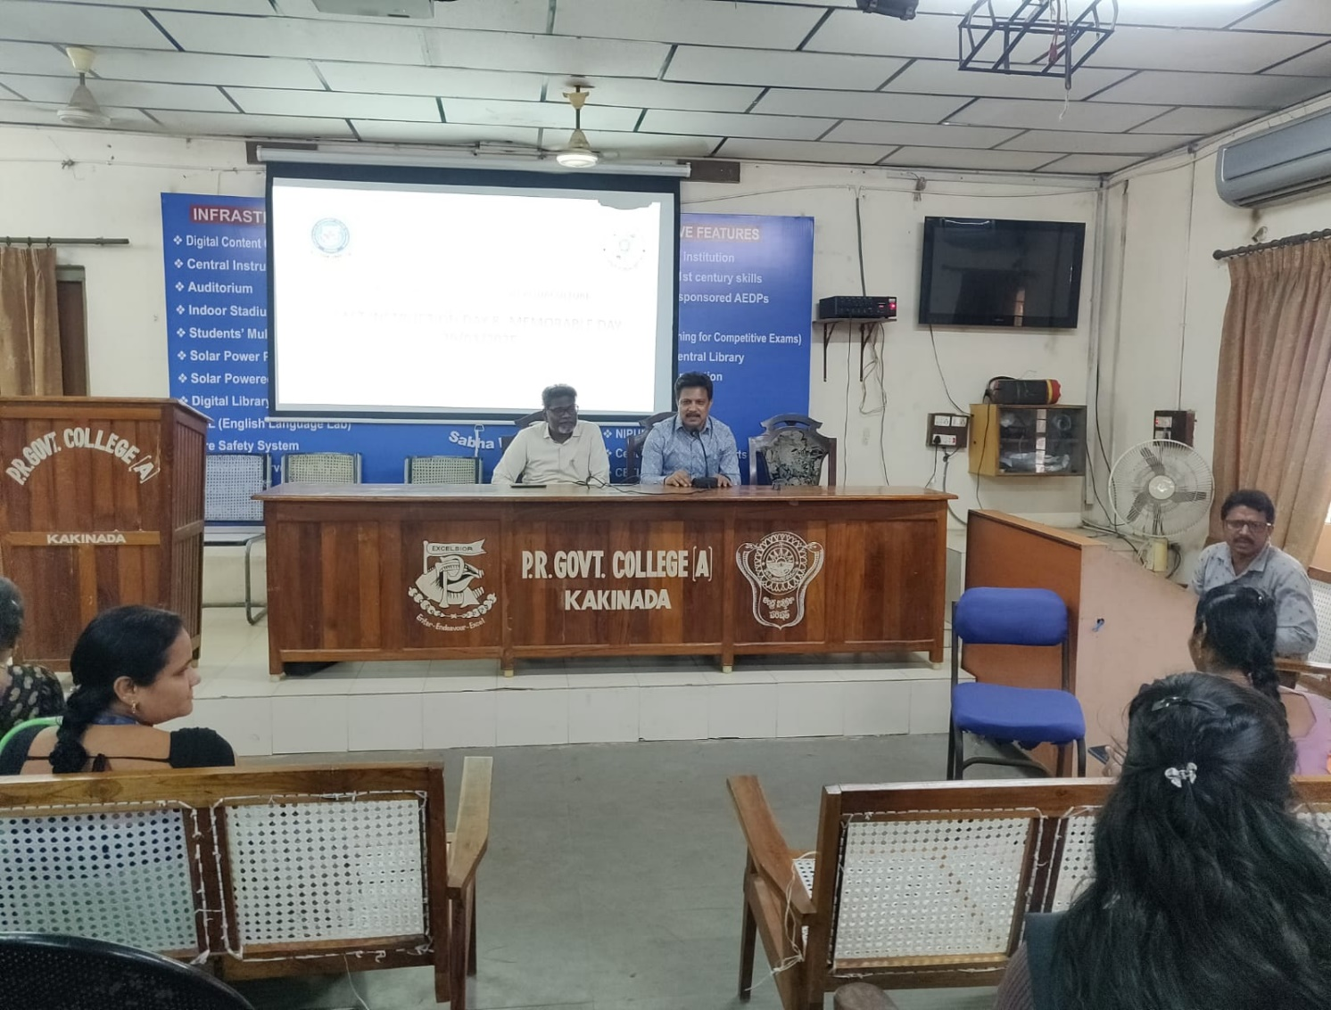

Opportunities Explained to Final year students

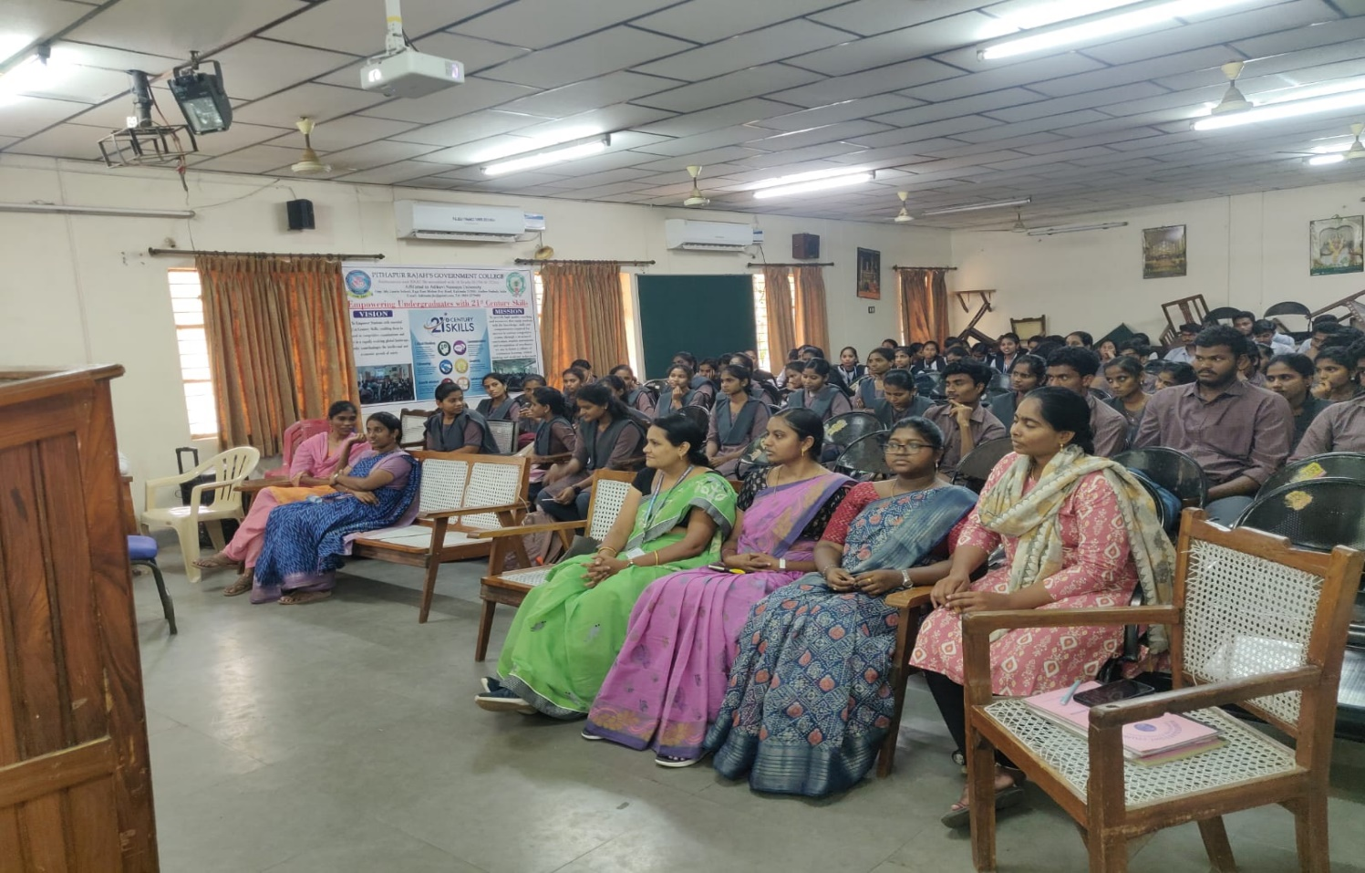

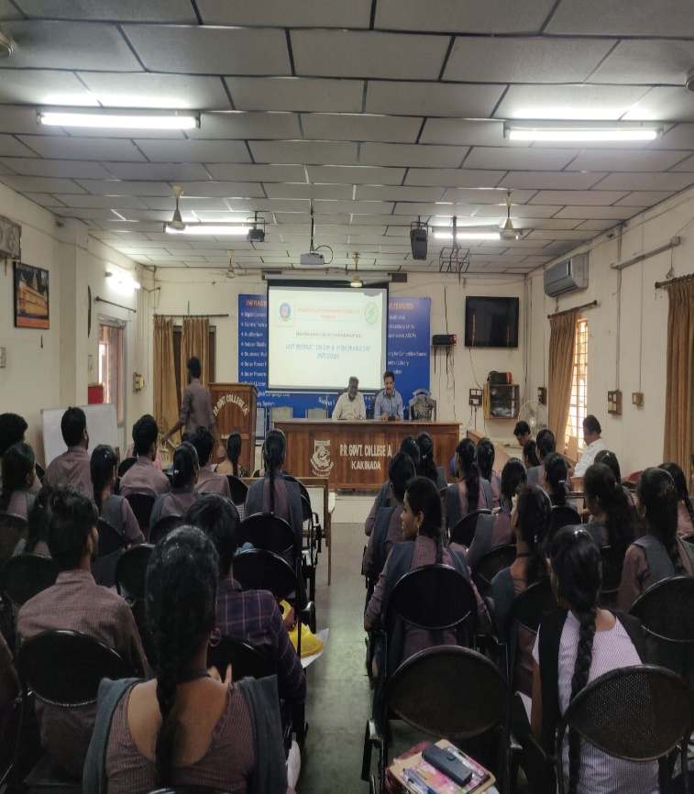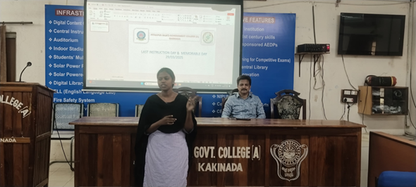

PGCET ORIENTATION

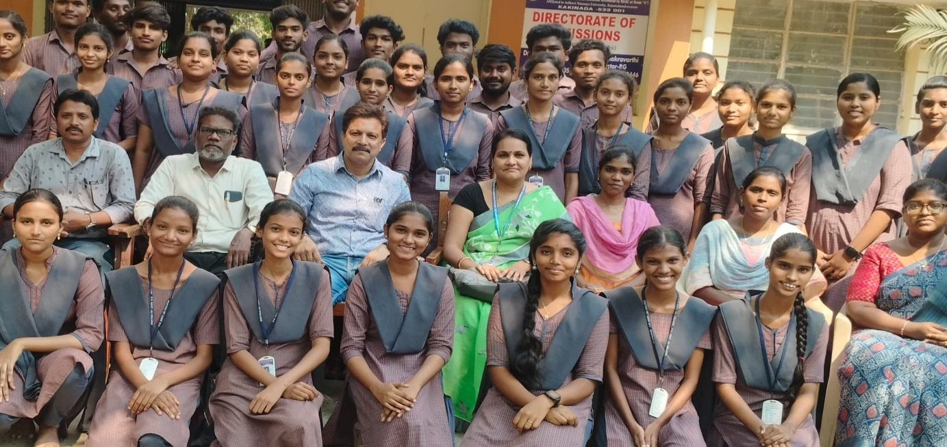

A jubilant moment at 2.00pm on 29-03-2025